Case 6 Afr-Ghana-Koma-Terracotta

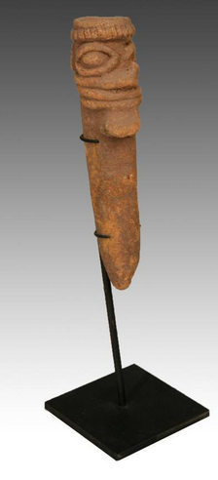 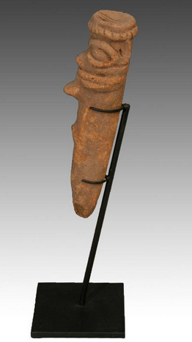

Antique Excavated Funerary Figure from the Koma People, who live in Northern Ghana, West Africa. The discovery of the so-called "Koma Terracotta’s" is one the richest and most important archaeological finds in African art, and have become well-known in the circles of art dealers, collectors and lovers of African art. The figurines were first discovered during archaeological fieldwork directed by Professor Ben Kankpeyeng (University of Ghana) during the 1980s and have been dated to between approximately 500 and 1300 AD. They were made by a previously little-understood people in what is known as Koma Land. The figurines are often fragmentary and depict stylized two-headed creatures, bird figures, animals, spiked heads, janus heads, and figurative forms. There is not a great deal of literature on how the figurines were used, but it has been suggested they were used in special ceremonies and rituals in which the spirits of the ancestors were invoked. It is possible that some had liquid offerings or libations poured into small channels burrowed into the tops of the figurines that exited through the nostrils or the mouth. Some have linked these channels with healing and medicine. In the course of ceremonies many figurines were deliberately broken. Later the fragments were buried in mounds, possibly because they were felt to have residual power and had to be disposed of carefully. When the Koma people began to farm the land where these pieces were found they were unearthed revealing the presence of an ancient culture. This superb piece measures 2.5 inches in width by 2.5 inches in depth by 8.5 inches high (6.35 cm by 6.35 cm by 21.5 cm). These pieces are now becoming exceptionally difficult to find on the art market. It is a superb collector’s piece and comes with a specially designed hand-made iron display stand

Price:

US $1,195.00

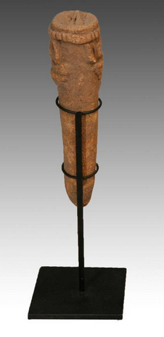**ANTIQUE TERRA COTTA FUNERARY FIGURE KOMA PEOPLE GHANA WEST AFRICA C.1300-1700 AD**